Event Posting

Winter 2018

JAGJIT SINGH BILKHU

**Description**

An event publishing web application to allow users to post events and schedule them for future. Also, they would be able to register to attend events and also save them. Users are also able to search for events or filter events based on the event type and select that specific event. Features/Functionalities:

* 1. Register/Login
  2. Post, Edit, Delete events
  3. Update user profiles
  4. Delete user account
  5. Logged out users would be able to only view events
  6. Register to attend event
  7. Save an event
  8. Filters/Search for events

<http://cs.tru.ca/~jbilkhuw8/Final_Project/Web_Files/userController.php>

**Page Layout**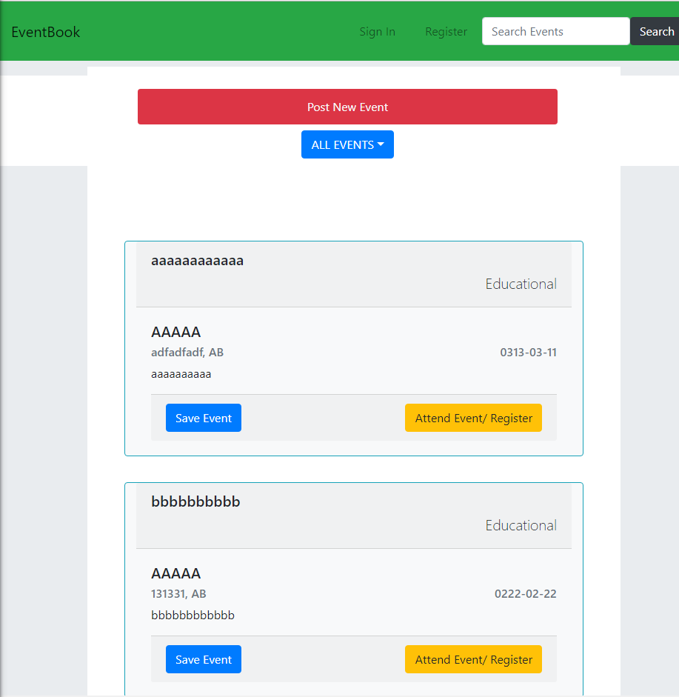

**Event Item Layout**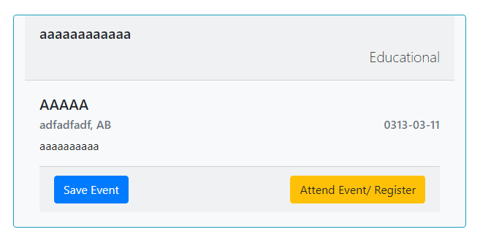

**Post Event Form Layout**

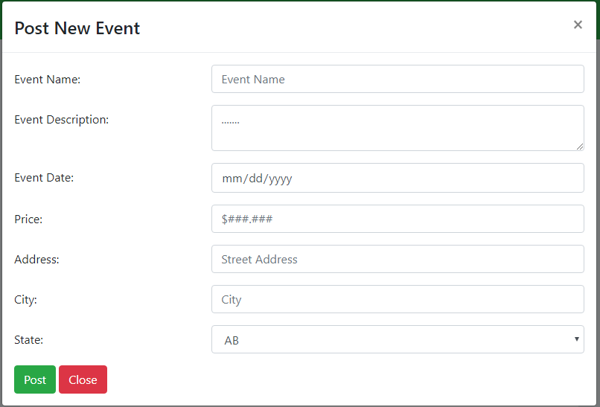

**List of user level features**

|  |  |
| --- | --- |
| Features | Descriptions |
| Login/Register | Users are able to sign up and login to the website |
| Post, Delete, Update new events | Users post events with names, descriptions and also set due dates |
| Set Interested Status | Users can set to be interested to attend events |
| Set Attending Status | Users can set attending status to events and notify the poster |
| Logged Out browsing | Logged out users can view public events |
| Filter/Search | Users are able to search for specific events based on event description and event titles. |
| Delete Account | Users can delete their accounts and this will delete all events that were posted by them |
| View Event Details | From the events list, users can click on an anchor to direct them to a new page to display the event details on a full screen |

**DB tables**

**Event Table: Stores events**

|  |  |  |
| --- | --- | --- |
| Columns | Data types | Descriptions |
| Name | Varchar | Name of event |
| Event city | Varchar |  |
| Time | Date |  |
| Posted By | Varchar |  |
| Public Event | Boolean | Is event public or private |
| Cost | Double cost of event |  |
| Type | Varchar | Type of event |
| Event state | VarChar |  |

**Users table: Stores users in the system**

|  |  |  |
| --- | --- | --- |
| Columns | Data types | Descriptions |
| Name | Varchar | Name of event |
| Email | Varchar |  |
| Password | Date |  |
| ID | Int |  |

**Attending Users table: Used to store the ids of users attending a specific event**

|  |  |  |
| --- | --- | --- |
| Columns | Data types | Descriptions |
| Event_id | Int |  |
| User_id | int |  |

**Interested Users table: Used to store the ids of users interested to attend a specific event**

|  |  |  |
| --- | --- | --- |
| Columns | Data types | Descriptions |
| Event_id | Int |  |
| User_id | int |  |

**Design**

**Mapping between files and MVC**

|  |  |  |  |
| --- | --- | --- | --- |
| File names | Model | Controller | View |
| home.php |  |  | Home page for signing up or logging in. Users are prompted to login to add or register for any events |
| userController.php |  | Handles users logging in and sessions from home.php |  |
| Logged_in.php |  |  | Logged in view file for logged in/registered users.  Users can post new events, update events or register for events |
| eventController.php |  | Handles event updates, posts and replies from the logged_in.php |  |
| Model.php | Model file to handle all database operations for users and events |  |  |
|  |  |  |  |

**Mapping between mandatory requirements and files**

|  |  |
| --- | --- |
| Requirements | File1 |
| User Session management | UserController |
| Event Posting, editing and retrieving | Event Controller |
| SPA: Filter saved events and attending events | Logged_in.php including filters, search, select events,  Also, myprofile page allows users to update their profile and edit/delete the events |
| Database operations and queries | Model.php |
| LoggedOut users | Home.php |
| User profile | Myprofile.php |

**File Methods and Functionality**

**Event.php**

This is a php class file to handle Event Objects and is also used to generate the Event Card layout with the event properties. This class is used in the event controller to process and parse the events returned from the database and create an HTML layout string returned to the view.

**EventController.php**

This file is a controller to handle all event queries and database operations. It has controls the following functions:

* + Show specific event details page
  + Display all events to logged out users
  + Post new events
  + Save / Get saved events
  + Register / Get registered events
  + Update / Delete events
  + Event search
  + Update / Delete account

This makes use of the Event.php class to process the events queried from the database to create html strings that are returned to the view.

**Home.php**

This is the main page view which is displayed to all logged out users. It displays a login and register modal and also provides filtering and searching functionality for users.

**LoggedIn.php**

This is the logged in view that is displayed when users login or register. Users can add new events, view saved events, view registered events, view profile and also edit/delete events. Users can also filter out the events based on their type.

**MyProfile.php**

This is also a view file that displays a user their posted events, and their profile information. Users can edit, delete their profile, edit events and delete events from this page.

**UserController.php**

This is a user session controller file that handles login and registration. It also handles updating profile and creates and deletes the stored cookie that has a user data.

**HomeStyles.css**

This is the css file that has been used to style the webpages.

**Model.php**

This handles all querying and actions on the database for both users and events.